**“Azerenerji” Open Joint-Stock Company**

**MIRIK AND GARIGISHLAG HYDROPOWER PLANTS**

**PROJECT INFORMATION NOTE**

SOCAR HYDRO BUNDLE-3, consisting of Mirik and Garigishlag Hydropower Plants is a small-scale bundled hydropower plant project which is implemented by “Azerenerji” Open Joint-Stock Company. The purpose of the project is to generate clean energy by harnessing the hydropower and providing the energy to the national electricity grid of Azerbaijan. By implementing the project, it is aimed to reduce dependency to the fossil fuels thereby reducing the sources of environmental pollution. Azerbaijan's green energy sector is developing, with a focus on transitioning to alternative and renewable energy sources, lowering carbon dioxide emissions.

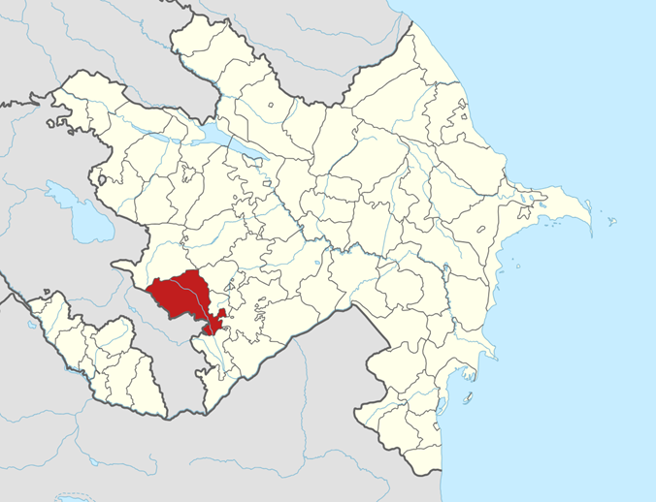

**Figure 1. Project area on the map**

Mirik and Garigishlag hydropower plants are located on Zabukh river, in the territory of Lachin district, Baku Province, Azerbaijan, with the purpose of contributing to the national economy the meeting the electricity demand.

**Figure 2. Location of the hydropower plants**

Both hydropower plants have been operational since March 2024. Total output of the power plants is limited at 7.1 MW. Electricity generated by both power plants is fed to the national electricity grid of Azerbaijan via 35 kV/110 kV Daşkesen HX substation.

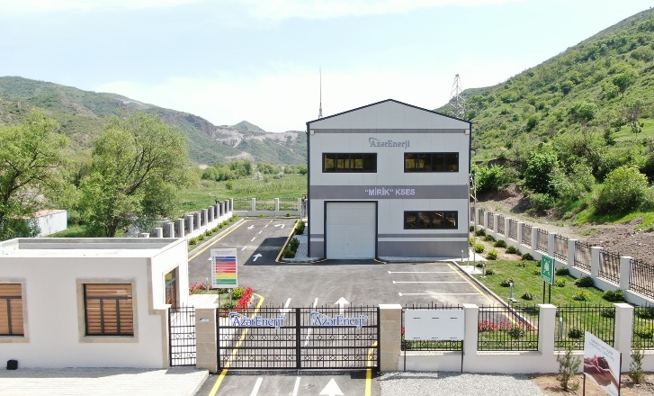

**Figure 3. Mirik (left) and Garigishlag (right) hydropower plants**

Since both hydropower plants have an installed capacity under 10 MW, preparation of an environmental impact assessment report and approval from the Ministry is not mandatory.

|  |  |  |  |
| --- | --- | --- | --- |
| **Power Plant Name** | **Installed Capacity (MW)** | **Emission Reduction (tCO2)** | **Electricity Generation (MWh/year)** |
| MIRIK HYDROPOWER PLANT | 3.3 | 3,864 | 9,504 |
| GARIGISHLAG HYDROPOWER PLANT | 3.8 | 4,450 | 10,944 |
| **Total** | **7.1** | **8,314** | **20,448** |

According to the calculations based on the amount of electricity generation, the project activity will contribute to the environment, air quality and especially the reduction of greenhouse gases that cause climate change by reducing approximately 8,314 tons of carbon dioxide (CO2) per year due to the use of renewable resources.

# MIRIK AND GARIGISHLAG HYDROPOWER PLANTS

**SUSTAINABLE DEVELOPMENT EVALUATION FORM**

|  |  |  |  |
| --- | --- | --- | --- |
| **Sustainable Development Indicators** | **Participant Comments** | | |
| **Positive** | **Negative** | **No Effect** |
| Air quality (Sulfur dioxide, nitrogen oxides, soot, etc.) |  |  |  |
| Water quality and quantity (Access to water resources) |  |  |  |
| Soil quality (Fight against erosion, soil pollution, etc.) |  |  |  |
| Other pollution sources (noise, light, etc. pollution sources) |  |  |  |
| Biodiversity (Effect on protected species) |  |  |  |
| Employment Quality (Working conditions, job security) |  |  |  |
| Combating Poverty (Impact on standard of living, access to health services, etc.) |  |  |  |
| Access to clean energy sources (Reliable, cheap energy, impact on energy imports) |  |  |  |
| Personal and institutional capacity (Education, awareness raising) |  |  |  |
| Contribution to employment and income level (New job opportunity, income increase) |  |  |  |
| Balance of Payments (Reducing foreign dependency, increasing investment) |  |  |  |
| Technology transfer and technological competence (Using, adapting, etc.) |  |  |  |

|  |  |  |  |
| --- | --- | --- | --- |
| **QİYMƏTLƏNDİRİCİ MƏLUMATLAR** EVALUATOR INFORMATION | **Ad Soyad**  Name Surname | |  |
| **Rayon/Vilayət**  District/Province | |  |
| **Qurum/Vəzifə**  Institution/Duty | |  |
| **Mobil Telefon**  Phone Number | |  |
| Layihə haqqında nəyi **müsbət** hesab edirsiniz? / What are the aspects that you find **positive** about the project? | | | |
|  | | | |
| Layihə ilə bağlı nəyi **mənfi** hesab edirsiniz? / What are the aspects that you find **negative** about the project? | | | |
|  | | | |
| **Tarix və İmza**  Date and Signature | |  | |

**KOMMUNİKASİYA / CONTACT**

|  |  |
| --- | --- |
| **Project Owner:**  “Azerenerji” Open Joint-Stock Company  **Address**: AZ1005, 10 Abdulkerim Alizade str. Baku Azerbaijan  **Phone:** +994 12 598 55 23  **E-mail:** info@azerenerji.gov.az | **Project Developer:**  SOCAR Trading SA  **Address:** Rue du Rhône 40, 1203  Geneva Switzerland  **Phone:** +41 22 562 00 00  **E-mail:** info@socartrading.com |